

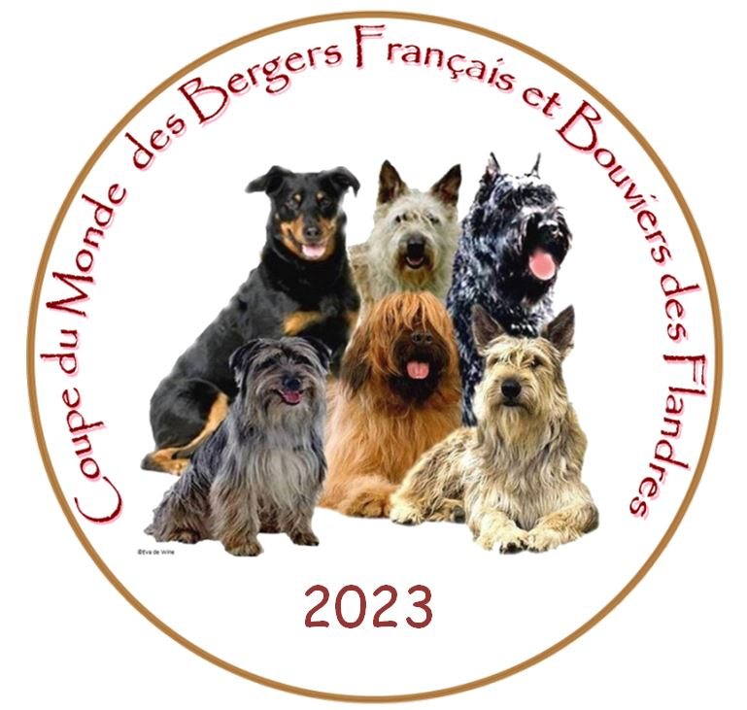
20. IGP WORLD CHAMPIONSHIP OF FRENCH SHEPHERDS AND BOUVIERS – C.M.B.F.
ZKO KLADNO–ŠVERMOV, BEAUCERON KLUB ČR, BOUVIER CLUB BOHEMIA, BRIARD KLUB ČR
DATE: 2. – 5. 11. 2023
VENUE: Football field, Vinarice, street Druzstevni (Kladno) – for categories IGP 1, IGP 2, IGP 3, FPr1+UPr1+SPr1, FPr3+UPr3+SPr3, IBGH1, IBGH3
GPS: 50°10'34.9"N 14°05'43.0"E (50.176357, 14.095270)
Breeds: Berger de Beauce, Berger de Brie, Bouvier des Ardennes, Berger des Pyrenees, Berger des Pyrenees, Bouvier des Flandres, Berger Picard
Categories: IGP 1, IGP 2, IGP 3, FPr1+UPr1+SPr1, FPr3+UPr3+SPr3, IBGH1, IBGH3
The competition will be held according to the International Utility Dogs Regulations http://www.kynologie.cz/zkusebni-rady.htm . Only dogs that have passed the BH or BH-VT exam can compete.
Judges: tracking - Karel Nedvěd, obedience - Ing. Jitka Jozová, main judge and protection - Martin Pejša, assistant judge – Věra Sedláková
Helpers: Jan Kuncl, Marek Hytych
Tracker layers: to be specified after the entry deadline
Event Manager: Ing. Pavel Baroš
email: cmbf2023@seznam.cz
Acceptance of applications only through CANIVA:
https://www.caniva.com/event/17420/Mistrovstv%C3%AD-sv%C4%9Bta-francouzsk%C3%BDch-ov%C4%8D%C3%A1k%C5%AF-a-flandersk%C3%BDch-bouvier%C5%AF-IGP-2023/
Deadline for applications: 2. 10. 2023
Entry fee - Category IGP 1 – 3: 1200,- Kč Other categories: 1000,- Kč
Foreign participants:: Category IGP 1 – 3: 52,- EUR Other categories: 43,- EUR
Payments: account no. 2700358379/2010 Fio Banka, account of Beauceron Club CR, variable
symbol 2023
Message for recipient: CMBF + handler's name + discipline
Payments from abroad: IBAN : CZ04 2010 0000 0027 0035 8379, BIC FIOBCZPPXXX
Message for the recipient: CMBF + handler's name + discipline
Account Owner: Beauceron Club of the Czech Republic, U Pergamenky 3, 170 00 Praha 7
Information site:: https://www.facebook.com/groups/628260945798519
Categories:
IGP1 - dogs with test max.IPO1, IGP1
IGP2 - dogs with test max.IPO2, IGP2
IGP3 – without restrictions
SPr1, UPr1, FPr1 - dogs with test max.SPr1, UPr1, FPr1
SPr3, UPr3, FPr3 - without restrictions
IBGH1 - dogs with test max.IBGH1
IBGH3 – without restrictions
The title "WORLD CHAMPION" will be awarded in IGP3 category if the minimum points limit for the exam is met (70 points in each section of the category). Valid for all breeds except Flanders Bouviers. The World Champion will eventually be the 1st dog of another breed.
In case of a tie 1. protection 2. obedience 3. tracking 4. draw
VETERINARY CONDITIONS
The dog's vaccination certificate must be presented by the handler at the veterinary inspection - rabies, distemper and parvovirus vaccinations must be valid. No dog with cropped ears will be allowed at the event.
The organizer shall not be liable for damages caused by the dog or handler or for death, injury or loss of the dog.
DOG handler - is obliged to behave in a correct and sporting manner during the whole event
- is responsible for any damage caused by them or their dog
- performs at their own risk during the event
- is obliged to follow the instructions of the organisers and the provisions of the
regulations
- is obliged to attend the check-in and veterinary acceptance
- is obliged to attend the opening ceremony and the drawing of the starting numbers
HANDLERS AND DOGS THAT DO NOT PASS THE CHECK-IN AND VET CHECK WILL NOT BE ALLOWED TO START.
ONLY THE HANDLER-DOG PAIR INDICATED ON THE ENTRY FORM MAY PARTICIPATE IN THE EVENT!!!
The handler shall present the following documents at the check-in and veterinary inspection
- the dog's vaccination certificate
- the dog's pedigree card
- scorebook or documents proving passing the required tests for the entered category (BH, BH-VT etc.)
During the whole event from the end of the official training until the end of the championship, no further training is allowed on the practice area. During the competition, only the competitor's dog that has passed the acceptance test, or the " pre-training dog " or the dog that is supplementing in the group of the last dog practicing obedience may enter the training area, but always only on the instruction of the organizer.
The use of inappropriate coercive devices (electronic or spiked collars, etc.) is prohibited throughout the event.
Failure to comply with the provisions of the regulations is grounds for disqualification of the competitor who violated the provisions.
A PROTEST can only be made for formal reasons in writing to the race director immediately after the defect is discovered and no later than the end of the discipline. A security deposit of CZK 1 000 must be paid, which is forfeited to the organiser if the protest is found to be unjustified.
A protest can only be lodged in matters relating to a breach of the ebent rules ort he International Utility Dogs Regulations. A protest cannot be lodged against a score.
PROGRAMME
Thursday, November 2, 2023:
10:00 a.m. - 3:00 p.m. Opportunity for a non-official training
15:00 - 17:15 ATTENDANCE, ACCEPTANCE AND VETERINARY INSPECTION
18:00 - 20:00 OPENING OF THE CHAMPIONSHIP AND DRAWING OF STARTING NUMBERS
20:00 - 22:00 GALA DINNER
Friday, November 3, 2023:
8:00 - 10:00 Training - Obedience
10:00 - 12:00 Training - protection
12:30 P.M. - 4:30 P.M. JUDGING FOR ALL CATEGORIES AS SCHEDULED
Saturday November 4, 2023:
7:30 a.m. - 4:30 p.m. ASSESSMENT OF ALL CATEGORIES BY SCHEDULE
Sunday, November 5, 2023:
7:30 a.m. - 1:00 p.m. ALL CATEGORIES JUDGING BY SCHEDULE
2:30 P.M. ANNOUNCEMENT OF ALL CHAMPIONSHIP CATEGORIES, CLOSING ceremony
The organizer reserves the right to modify the programme and the provisions of the regulations with regard to the number of dogs entered. Any changes will be announced in due time.
!!! Bitches in heat, please report to the organizer as soon as possible!!!
Accommodation and catering
Catering: provided at the training area for IGP (Vinarice). Meal menu will be published after the deadline.
Accommodation options :
Restaurant U jezírka, Tuřany 157, 273 79 Tuřany u Slaného, tel: 607 504 677, 607 725 515 e-mail: ujezirka@seznam.cz, www.ujezirka.cz - insulated cabins without heating, but great for dogs and excellent cooking. An area for the possibility of training natural habitats or rescue training on the paintball field
Areál Botanika, Horní Bezděkov 154, 273 51 Horní Bezděkov, tel: +420 604 938 525, e-mail: areal.botanika@vysehrad2000.cz, https://arealbotanika.cz
Restaurace a penzion Žilina, Družecká 153, 273 01 Žilina, e-mail: penzion@vedox.cz , tel: +420 774 454 415, https://penzion-zilina.cz
Penzion a stáj Bílichov, Bílichov 102, 273 74 Bílichov, e-mail: info@bilichov.eu tel: +420 777 480 738, https://bilichov.eu
Hotel Hejtmanský dvůr, Masarykovo náměstí 114, 274 01 Slaný, e-mail: hotel@hhd.cz tel: +420 777 616 777, www.hhd.cz
Location:

The IGP, check in and veterinary check will be on site:
Vinarice, Druzstevni, Football field GPS: 50°10'34.9"N 14°05'43.0"E (50.176357, 14.095270)

The OBEDIENCE will be on site:
Kladno - Svermov, ulice Za Skolou (K Brezinam) 765, Kynological area GPS: 50°09'56.9"N 14°05'42.2"E (50.165792, 14.095050)

The AGILITY will be on site:
Kladno, Doberska - sports Hall, GPS: 50°08'01.3"N 14°04'02.7"E (50.133699, 14.067416)

Opening (draw) and gala dinner - Lidice, Tokajicka 152 - Restaurant Galerie Lidice, GPS: 50°08'36.3"N 14°11'21.3"E

50.143403, 14.189240

